This Week
Our Praise Theme
Together we praise God who answers all!
Our Prayer Theme
Together we pray that we cultivate transparent, meaningful relationships so much that remaining anonymous appears strange
Our Memory Verse
being confident of this very thing, that He who has begun a good work in you will complete it until the day of Jesus Christ;
~ Philippians 1:6
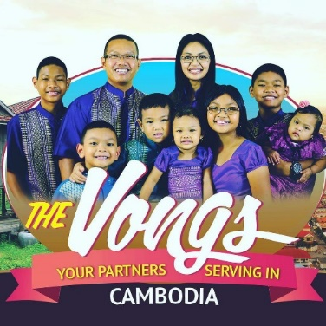
Our Missionary
The Vongs are Cambodian Americans who returned to their motherland as missionaries in 2015. Please pray for them as they preach the gospel, make disciples and establish churches. Also pray for their safety and provision as they continue building their first church building.
Our Gatherings
Sunday @ 10:30 AM Sunday Worship Service
Sunday @ 5:00 PM Sunday Evening ONLINE ONLY

See your group leader for Discipleship group meeting plans

Events Coming Up
- June 13th , Saturday – Faithful Men’s Meeting
Announcements
June 13th – Faithful Men’s Meeting
The monthly men's meeting is this Saturday in the Church Fellowship Hall at 6:00 PM. Come prepared to discuss chapter three of the companion study book. This book may be purchased in the church bookstore or online.

Connect with Us!
Pastor Jack Lamb 626.484.4346
Pastor Allen Cox 626.678.0106
Church Office 626.869.9034 (Mon, Tues, Thurs, Fri)
Website www.ouranchorholds.com
Facebook www.facebook.com/ouranchorholds
My Prayer Journal
______________________________________________________
______________________________________________________
______________________________________________________
______________________________________________________
______________________________________________________
______________________________________________________
______________________________________________________
______________________________________________________
______________________________________________________
______________________________________________________
______________________________________________________
______________________________________________________
____________________________________________________________________________________________________________
______________________________________________________
______________________________________________________

